# DESIGN AND DEVELOPMENT OF A WEB-BASED APPLICATION NAMED “PET CARE MANAGEMENT SYSTEM” (PCMS)

### BY

**Md Rakibul Islam ID: 201-15-3369**

# FINAL YEAR DESIGN PROJECT REPORT

This Report Presented in Partial Fulfillment of the Requirements for the Degree of Bachelor of Science in Computer Science and Engineering

# Supervised By

### Mr. Mahimul Islam Nadim

Lecturer

Department of Computer Science and Engineering Daffodil International University

# Co-Supervised By

### Mr. Tanvirul Islam

Lecturer

Department of Computer Science and Engineering Daffodil International University



# DAFFODIL INTERNATIONAL UNIVERSITY

**DHAKA, BANGLADESH**

# July 2024

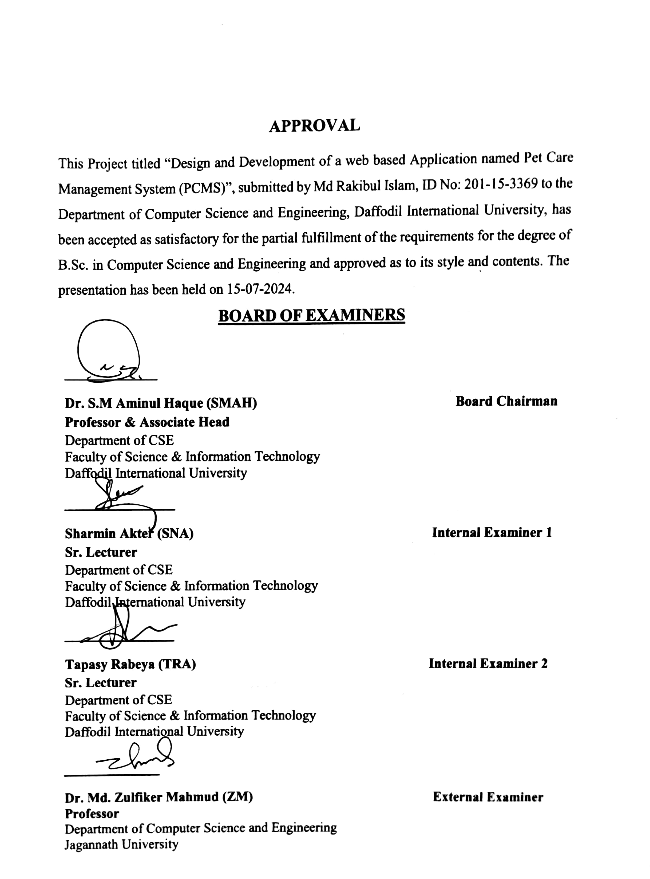

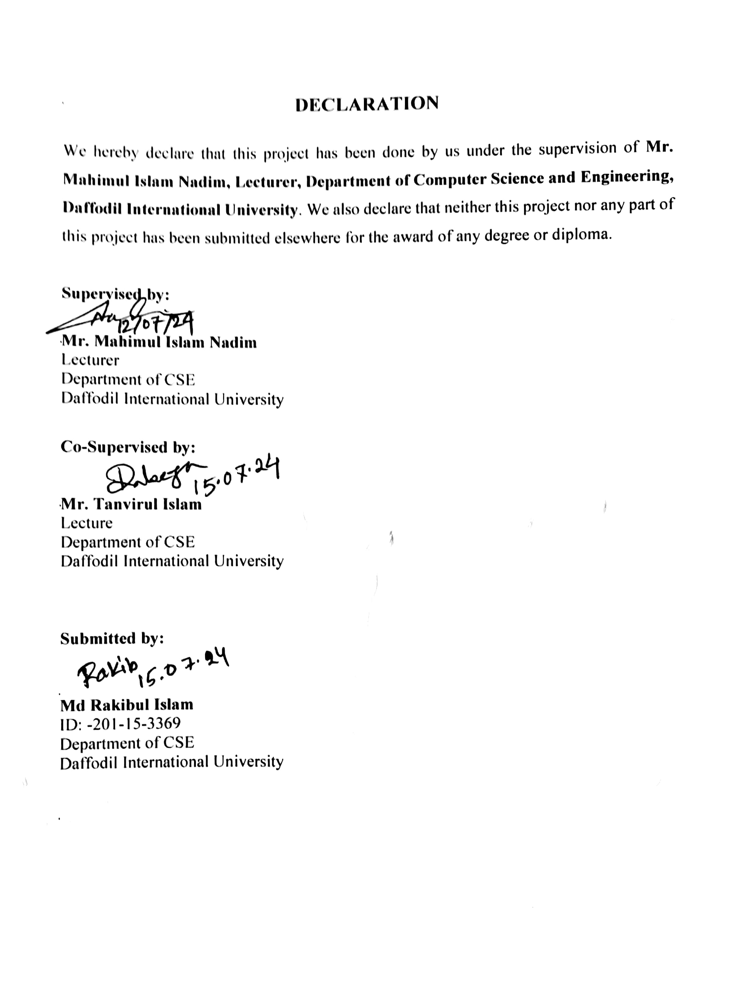

# ACKNOWLEDGEMENT

First, we express our heartiest thanks and gratefulness to almighty for His divine blessing making it possible for us to complete the final year project/internship successfully.

We are grateful and wish our profound indebtedness to **Mr. Mahimul Islam Nadim**, **Lecturer**, Department of CSE Daffodil International University, Dhaka. Deep Knowledge & keen interest of our supervisor in the field of “*Web Design and Development*” to carry out this project. His endless patience, scholarly guidance, continual encouragement, constant and energetic supervision, constructive criticism, valuable advice, reading many inferior drafts, and correcting them at all stages have made it possible to complete this project.

We would like to express our heartiest gratitude to the **Dr. Sheak Rashed Haider Noori Head of the Department of CSE**, for his kind help in finishing our project and also to other faculty members and the staff of the Department of CSE, Daffodil International University.

We would like to thank our entire course mate in Daffodil International University, who took part in this discussion while completing the course work.

Finally, we must acknowledge with due respect the constant support and patience of our parents.

# ABSTRACT

The Pet Care Management System is a web-based application that simplifies the pet care management system on online. The web application is a great resource for the pet owner who struggles with their pet's nutrition food and health care. By using the pet care management system website pet owners find nutritious food, pet furniture, pet medicine, and medical services. The primary objective of this website is to ensure the proper health of pets. The website is a multi-vendor type website. where different sellers can sell their products on this website. The website is built using MERN stack technology. Where the front end is built using React.js, and TailwindCSS, and the back end is built using Node.Js and Express.Js. Here MongoDB is used as a database. The implementation of the MERN stack ensures scalability, flexibility, and responsiveness of the application, making it accessible from various devices and platforms. The use of MongoDB provides a flexible and scalable database solution, while Express.js and Node.js facilitate efficient server-side development and API integration. React.js enables the creation of dynamic and interactive user interfaces, enhancing the overall user experience. Through this project, we aim to address the challenges faced by pet owners in managing their pets' care routines and foster better communication and collaboration between pet owners and service providers. The Pet Care Management System offers a modern, efficient, and user-centric solution to streamline pet care management and promote the health and well-being of pets worldwide.

|  |  |
| --- | --- |
| **TABLE OF CONTENTS** |  |
| **CONTENTS** | **PAGE NO** |
| **Approval** | ii |
| **Declaration** | iii |
| **Acknowledgement** | iv |
| **Abstract** | v |
| **Table of contents** | v |
| **List of figures** | viii |
| **CHAPTER 1****:** **INTRODUCTION** | **1****-6** |
| 1.1 Overview | 1 |
| 1.2 Background and Present State | 1 |
| 1.3 Problem Statement | 3 |
| 1.4 Objectives | 3 |
| 1.5 Scope and Limitations | 4 |
| * 1. Report Organization   2. Summary | 5  6 |
| **CHAPTER 2:** **BACKGROUND** | **7****-13** |
| 2.1 Overview | 7 |
| 2.2 Related Work | 7 |
| 2.3 Comparison between existing works | 11 |
| 2.4 Open Issues | 12 |
| 2.5 Summary | 13 |

|  |  |
| --- | --- |
| **CHAPTER 3****: METHODOLOGY/ REQUIREMENT**  **ANALYSIS & DESIGN SPECIFICATION** | **14****-19** |
| 3.1 Overview | 14 |
| 3.2 Proposed Methodology/ System Design | 14 |
| 3.3 Hardware/ Software Requirement | 17 |
| 3.4 Project Management and Financial Analysis | 18 |
| 3.5 Summary | 19 |
| **CHAPTER 4:** **IMPLEMENTATION** | **20-25** |
| 4.1 Overview | 20 |
| 4.2 Train Model/ Prototype Design | 20 |
| 4.3 System Testing/ Model Evaluation | 23 |
| 4.4 Summary | 25 |
|  | **26-31** |
| **CHAPTER 5:** **RESULT AND ANALYSIS** |  |
| 5.1 Overview | 26 |
| 5.2 Experimental/ Simulation Result | 26 |
| 5.3 Performance/ Comparative Analysis | 30 |
| 5.4 Summary | 31 |
| **CHAPTER 6:****IMPACT ON SOCIETY,****ENVIRONMENT AND SUSTAINABILITY** | **32-37** |
| 6.1 Impact on Society | 32 |
| 6.2 Impact on Environment | 32 |
| 6.3 Ethical Aspects | 34 |
| * 1. Sustainability Plan   2. Summary | 35  37 |

|  |  |
| --- | --- |
| **CHAPTER 7****:** **CONCLUSION AND FUTURE SCOPE** | **38-40** |
| 7.1 Discussion and Conclusion | 38 |
| * 1. Scope for Further Developments   2. Limitations/ Conflict of Interests | 38  40 |
| **REFERENCES** | **41** |
| **APPENDIX A**  **COURSE OUTCOMES, COMPLEX ENGINEERING**  **PROBLEMS (EP) AND COMPLEX ENGINEERING ACTIVITIES (EA) ADDRESSING** |  |
| **APPENDIX B** |  |

# LIST OF FIGURES

|  |  |
| --- | --- |
| **FIGURES** | **PAGE NO** |
| Figure 2.2.1 Home Page of PetBangla.com | 9 |
| Figure 2.2.2 Home Page of Pet Paradise Bangladesh | 9 |
| Figure 2.2.3 Home Page of BDPets.com | 10 |
| Figure 3.2.1 3-tier Architecture | 15 |
| Figure 4.2.1 Business Process Modelling | 21 |
| Figure 4.2.2 Use Case Diagram. | 22 |
| Figure 4.3.3 Logical Data Modeling | 23 |
| Figure 5.2.1 Database Architecture | 27 |
| Figure 5.2.2 Landing Page Design | 27 |
| Figure 5.2.3 Appointment Page design. | 28 |
| Figure 5.2.4 Shop Page Design | 28 |
| Figure 5.2.5 Admin Dashboard Design | 29 |
| Figure 5.2.6 Seller Dashboard Design | 29 |
| Figure 5.2.7 Doctor Dashboard Design. | 30 |

**LIST OF TABLES**

|  |  |
| --- | --- |
| **TABLES** | **PAGE NO** |
| Table 3.4.1: Estimated Cost for The Pet Care Management System | 19 |

# CHAPTER 1

**Introduction**

### Overview

Pet Care Management System (PCMS) is a web-based application using MERN Stack to make a change in the entire pet care management system. The main goal of this application is to make it easier for the pet owner to look after the health and welfare of their beloved animals. The website is a multi-vendor type website. Here the application allows the sellers to upload their pet food, medicine, and consumables. They also allow the seller to manage products, delete products, hide products, and many more. The application also allows The doctors to see their appointments and also allows the doctors to delete appointments or reschedule the appointment. By using our user-friendly search bar user can easily find their desired product. PCMS not only saves our time but is also helpful for every pet owner.

### Background and Present State

A significant vacuum in pet care services is filled by the Pet Care Management System (PCMS), especially in rural and small-town settings where access to wholesome pet food, necessary medications, and veterinary care is frequently restricted or nonexistent. The desire to address these issues led to the development of PCMS as a pet lover who has personally witnessed the difficulties in providing appropriate care for pets in smaller areas.

Many rural pet owners currently have major challenges in ensuring the health and wellbeing of their animals. An absence of dependable doctor services and high-quality pet food results in less than ideal care for animals, even when their owners have the best of intentions. The dearth of infrastructure and resources in the area devoted to pet care exacerbates this predicament, leaving pet owners disgruntled and possibly endangering their animals.

Existing online pet care systems in Bangladesh and similar contexts are either too small in scope or do not sufficiently address the particular difficulties faced by rural pet owners. These platforms usually focus on urban areas or lack comprehensive features, including trusted product listings, easily accessible medical consultations, and community support for pet owners. This disparity emphasizes the need for a specialized solution like PCMS, which attempts to combine necessary resources and services for pet care into an approachable web platform.

PCMS aims to provide a comprehensive solution that allows pet owners to browse and buy pet products, book doctor appointments, and access educational material on pet care by utilizing the capabilities of the MERN Stack (MongoDB, Express.js, React.js, Node.js). Because of the platform's multi-vendor concept, local retailers can market their goods, increasing the selection of pet care supplies available and encouraging community involvement.

Basically, PCMS aims to close the information gap that exists between pet owners in underserved areas and necessary pet care providers. The platform's all-encompassing strategy and accessibility focus seek to enable pet owners to give their beloved animals the best care possible, irrespective of their location or ability to access conventional pet care services.

### Problem Statement

The growing number of people who adore animals, particularly in rural regions, emphasizes how urgently we need more resources for pet care. Pet owners in rural areas, however, frequently face challenges related to inadequate facilities, restricted availability of wholesome pet food, and a dearth of veterinary care. Even among pet owners who are willing to give their furry companions the finest care possible, this circumstance leads to poor health care for animals. My website attempts to close these gaps by providing a thorough fix. It will offer educational materials such as dietary guidelines, wellness and health advice, and pet care manuals. The site will also advertise mobile veterinary services and make it easier for people to seek veterinary care by providing a database of local veterinarians and online consultations. In addition to partnering with local suppliers to stock these products in village shops, an online store will provide premium pet food with delivery options to address the problem of pet food scarcity. Through forums, activities, and volunteer opportunities, the website will also promote community involvement and build a network of pet owners who can support one another. Features that provide emergency support, such as a special hotline and first aid kits, will guarantee that pets receive care in a timely manner. The website will be helpful to pet owners in rural areas and accessible with a user-friendly, mobile-compatible design and local language material, ensuring the well-being of their pets.

### Objectives

The main goals of this Project are:

* Provide pet owners a user-friendly interface to access necessary for pet care, like nutritious food, medicine, and medical services.
* Facilitate easy browsing and purchasing of pet products from multiple vendors through a centralized online marketplace.
* Establish strict security measures in place to secure user data, maintain system integrity, and fend off cyberbullies.
* Provide pet owners the option to make appointments for medical consultations and treatments with doctors.
* Make it easier for those who live in rural or small communities and have limited access to traditional pet care facilities to access high-quality pet care services.
* Enhance the overall well-being of pets by ensuring they receive proper nutrition, medication, and medical attention, ultimately strengthening the bond between pets and their owners.
* Design the platform to be scalable, allowing for easy expansion and adaptability to future technological advancements and industry changes.
* Create a forum for pet owners to exchange stories, pointers, and counsel on taking care of their animals in order to encourage a feeling of community among them.
* Continuously evolve and update the PCMS platform to incorporate feedback from users and adapt to changing needs and preferences in the pet care industry.

All of these goals work together to provide a solid, user-friendly web-based travel management system (TMS) platform that meets the demands of consumers, organizers, and system administrators while transforming the effectiveness and ease of trip administration.

### Scope and Limitation

PCMS, or the Pet Care Management System, tackles a wide range of issues that affect pet owners, especially those who live in areas where resources and services for pet care are limited. Finding nutritious pet food, necessary medications, and medical treatment can be challenging in these situations, particularly in rural or small town locations. Pet owners must navigate various platforms to meet all of their demands because current pet care management platforms frequently focus on particular facets of pet care. By providing a comprehensive solution and a centralized platform where pet owners can obtain a variety of goods and services, such as food, medication, and medical professional consultations, all in one location, PCMS aims to reduce this burden. Furthermore, the multi-vendor model of PCMS offers pet care businesses a chance to grow customers and revenue. As a result, PCMS not only meets the requirements of pet owners but also offers chances for pet care businesses to grow in the digital age.

There are several limitations with the Pet Care Management System (PCMS). Its efficacy is mostly dependent on internet connectivity, which in certain rural locations may be scarce or unstable. The availability and willingness of nearby pet care companies to sign up and take an active part in the platform is another factor that determines the success of the multi- vendor model. Furthermore, there may be logistical difficulties involved in transporting tangible goods or offering in-person services to far-flung locations, which could affect the accessibility and dependability of PCMS services. Furthermore, even while PCMS strives to provide a wide range of services, not all regions may have access to all specialized or urgent care services, which could compromise the platform's overall comprehensiveness.

### Report Organization

This report outlines the comprehensive development and impact analysis of the Pet Care Management System (PCMS). It begins with an introduction to PCMS, detailing its objectives, scope, and significance in the pet care industry. Following this, the methodology section delves into the technical and strategic approaches used in designing and implementing PCMS, including phases such as requirement analysis, system design, development, testing, and evaluation. The results and analysis section discusses the outcomes of PCMS, highlighting user feedback, system performance metrics, and security assessments. A detailed exploration of PCMS's societal and environmental impacts follows, focusing on improvements in pet care efficiency, accessibility, and sustainability practices. Ethical considerations and a sustainability plan are also addressed, emphasizing data privacy, fair treatment of vendors, and environmental responsibility. The conclusion reflects on PCMS's achievements and future prospects, discussing innovations like mobile integration, AI utilization, and global expansion. Finally, limitations and conflicts of interest are examined, ensuring a balanced perspective on challenges and mitigation strategies. This report aims to provide a comprehensive understanding of PCMS's development, impact, and future directions.

.

### Summary

Nowadays finding nutritious food, medicine, and doctor's services for pets is a great problem. Maximum time villages or small town’s people face this problem. Pet Care Management System Aim is to provide nutrition food, medicine, and doctors services. This website is a resource hub for pet owners. On one website they found everything for their pets.

# CHAPTER 2

**Background**

### Overview

I will discuss about my project, the "Pet Care Management System" (PCMS), and make comparisons with other initiatives of a similar nature in this chapter. My website has many aspects in common with other pet care websites, even though I've tried to make it look distinct. In order to meet the needs of all pet owners, PCMS provides complete services for nutrition and health. To place food or medication orders or schedule doctor's visits, users must log in. Users who have logged in can manage their orders, appointments, and personal information on a dashboard. Users can also use the messaging or phoning facilities in our admin panel to get in touch with us if they have any problems. All in all, pet owners will find the website to be highly user-friendly and smooth.

### Related Work

The companion study for "PCMS - Pet Care Management System" includes research on pet care management, user interfaces, security, and customized services, in addition to a review of comparable platforms and technologies. This synopsis lists pertinent books and websites:

* Available Pet Care Platforms: Evaluate current web-based pet care management platforms to determine their benefits, drawbacks, and features. Examine platforms like PetBangla.com, Pet Paradise Bangladesh, or BdPets.com administration software to get knowledge about the features, innovations, and user experiences in the pet care field.
* User Interface and Experience (UI/UX): Research UI/UX best practices and recommendations for web applications, with an emphasis on user engagement, smooth navigation, and intuitive interfaces. Examine well-known pet care websites and apps to find efficient PCMS design techniques.
* Security Measures in Web Applications: Examine compliance standards, encryption techniques, and industry-standard security processes to ensure platform security and

user data protection. Examine case studies and research papers on creating safe web apps to put strong security measures in place in PCMS.

* Agile Development Methodologies: Study up on case studies or related material regarding the use of Agile approaches in the creation of web applications. Think about how the development of complicated systems such as PCMS can be aided by collaborative and iterative approaches.
* Academic Research in Pet Care Management: Look through academic publications, journals, and conference proceedings on subjects related to pet care, such as user behavior analysis, platform satisfaction, and technology developments in pet care administration.
* Industry Trends and Inventions: Discover the most recent developments, cutting-edge technologies (including blockchain and IoT), and inventions in the pet care sector. Examine the potential effects these advancements may have on PCMS's features and architecture.

There are many pet care-related websites on the internet. These websites are based on a single vendor. Some sell pet food and some sell pets. Some sell pet consumables.

Examples of Some pet care-related websites:

1. PetBangla.com[1]
2. Pet Paradise Bangladesh[2]
3. BdPets.com[3]
4. PetBangla24.com[4]
5. Bangladesh Kennel Club[5]
   1. PetBangla.com: Here Example of PetBangla.com

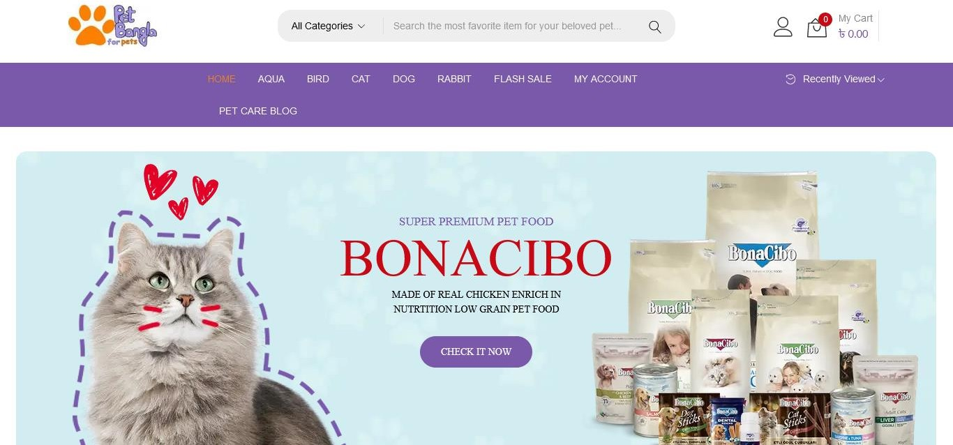

Figure2.2.1: Home Page of PetBangla.com

Here the website name is PetBangla.com[1]. On this website, I see that the website is selling pet food for pet owners. The user interface is nice but they need to update it more. For food ordering a user needs to sign in first, then they will able to order food.

* 1. Pet Paradise Bangladesh: Here Example of Pet Paradise Bangladesh

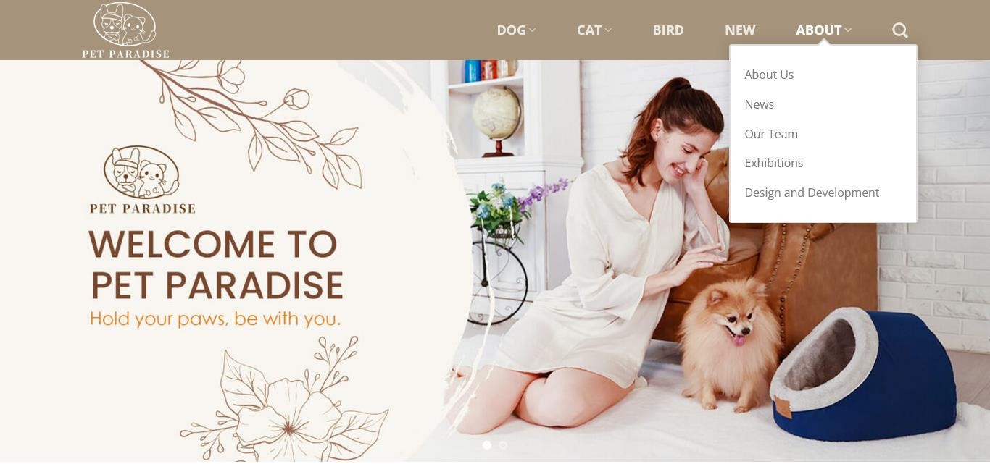

Figure 2.2.2: Home Page of Pet Paradise Bangladesh

Here the website name is Pet Paradise Bangladesh[2]. On this website, I see that the website is selling pet furniture for pet owners. The user interface is nice but they need to update it more. For pet furniture ordering the owner needs to sign in first, then they will able to order petfurniture.

* 1. BDPets.com: Here Example of BDPets.com

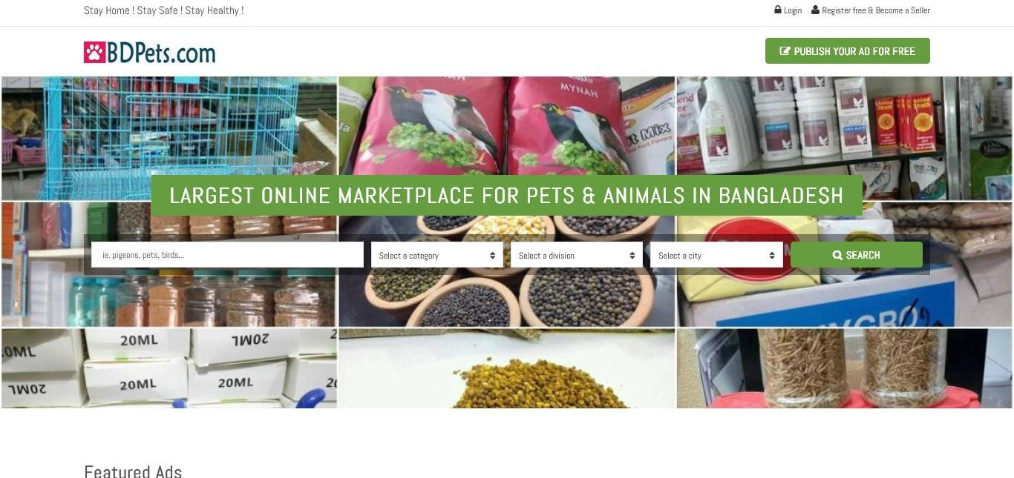

Figure2.2.3: Home Page of BDPets.com

Here the website name is BdPets.com[3]. On this website, I see that the website is selling pets for pet owners. The user interface is nice but they need to update it more. This website is a single vendor-type website. User sign-in is a must for pet buying from this website.

The integration of findings from relevant research will yield significant information, guidelines, and concepts for the creation, layout, and improvement of the "PCMS - Pet Care Management System."

### Comparison between existing works

The process of doing a comparative analysis for "PCMS - Pet Care Management System" involves assessing comparable current platforms or systems in the market. Take into consideration the following organized breakdown for a comparative analysis:

* Platform Features and Functionalities:
* Check out the features that leading pet care management websites, like BdPets.com and PetBangla.com, have to offer. Examine features related to dashboards, appointment scheduling, pet care scheduling, and customization options.
* Explain how PCMS differs from other applications in terms of features, usability, and advanced capabilities.

## User Interface (UI) and Experience (UX):

* Analyze the UI/UX, design, navigation, responsiveness, and aesthetic appeal of well- known platforms. Analyze how user-friendly and intuitive their interfaces are.
* Examine PCMS's UI/UX design with an emphasis on the user's entire experience, visual appeal, usability, and interactivity.

## Security and Privacy Measures:

* Verify the security and privacy protocols implemented by reputable pet care management platforms to guarantee the safety of user information and transactions.
* Examine PCMS's security features, user data protection policies, encryption methods, and compliance with industry standards and laws.

## Personalization and Recommendation Systems:

* Examine how rivals tailor pet care offerings to individual users' tastes and behavior, and provide recommendations accordingly.
* Examine how PCMS uses user data to create individualized pet care plans, how successful and sophisticated its recommendation engine is, and how much customisation it offers users.

## Customer Support and Engagement:

* Examine rival systems' customer service options (live chat, FAQs, support tickets) and engagement tactics (loyalty programs, feedback methods).
* Examine PCMS's customer service offerings, customer retention tactics, and level of responsiveness.

## Market Position and User Reviews:

* Examine market share, ratings, reviews, and comments from users of the best pet care management platforms to find out what needs to be improved and to gain insight into the problems and contentment of your customers.
* Analyze PCMS's launch reception, beta testing feedback, and areas where it performs better or requires improvement in comparison to other products.

A thorough comparative analysis will offer vital information about the advantages, disadvantages, opportunities, and threats that "PCMS - Pet Care Management System" faces. This information will enable improvements and modifications to be made in order to maintain a competitive advantage in the market.

### Scope of the Problem

As the Pet Care Management System (PCMS) works to transform the supply of pet care, it faces a number of significant challenges. Ensuring smooth compatibility among its many technologies is a critical challenge. PCMS must perfectly integrate elements like databases, web servers, and user interfaces in order to create a strong and flexible website. Convincing people to switch from their existing ways of getting pet-related products to PCMS is another significant task. In order to draw in and keep users, PCMS must be incredibly feature-rich and easy to use.

Another challenge is finding a wide range of pet product sellers and vetting the caliber of their products. From vendor onboarding to product quality verification, PCMS needs to carefully handle these aspects. It's also crucial to protect user privacy when using PCMS. This necessitates putting strict security measures in place to safeguard data and abide by privacy laws.

Last but not least, it is a significant duty to guarantee that PCMS operates efficiently across all platforms, including PCs and mobile devices. To ensure its dependability and usability across many access points, extensive testing is necessary.

By overcoming these obstacles, PCMS has the potential to develop into a useful tool for pet care that prioritizes user security and experience while providing quick access to necessary goods and services.

### Summary

Pet food, furniture, medications, and medical services are just a few of the demands that can be met by the cutting-edge Pet Care Management System (PCMS). My research revealed a huge gap in the market since the majority of websites now in existence concentrate on selling certain products, such as food, furniture, or pets, but none provide pet owners with a whole package. PCMS seeks to bridge this gap by offering a cohesive solution. To ensure a customized experience, users must log in before making purchases or scheduling a doctor visits. Additionally, as a multi-vendor website, PCMS provides a great chance for young businesses to start their online enterprises, fulfilling the demands of pet owners while also encouraging new business endeavors.

# CHAPTER 3

**Methodology / Requirement Analysis & Design Specification**

### Overview

A web application built using the MERN (MongoDB, Express, React, and Node) stack, the Pet Care Management System (PCMS) has been developed to offer complete online pet care services. Its goal is to establish a comprehensive platform that allows pet owners to oversee the requirements of their pets. There are various important steps in the development process. In order to manage users, I must first put in place an authentication system and generate user profiles. I then have to set up service management, which includes selling pet supplies, food, furniture, and medications as well as scheduling doctor's appointments. A customized experience requires designing dashboards for users, vendors, and admins. Additionally, managing different sellers requires the implementation of a multi-vendor management system. Providing strong security and privacy protections in addition to online medical services is a top goal. Developing an interface that is easy for consumers to navigate and locate what they need is crucial, to sum up.

### Proposed Methodology/ System Design

Front-end and back-end development are the two essential development components needed to create the Pet Care Management System (PCMS). The MERN stack is used in the system's modular architecture, which consists of the following parts:

### Front-end Design

The Pet Care Management System (PCMS) website, built on the MERN (MongoDB, Express.js, React.js, Node.js) stack, embodies a modern and user-centric front-end design. Using responsive design concepts ensures seamless compatibility with a wide range of screens and devices. The UI is designed with ease of use in mind, making it simple to navigate and quickly access key features like managing user profiles, booking appointments, and browsing products. Vibrant images and interactive components are

examples of visual aspects that improve both aesthetic appeal and user engagement. In order to provide a simple and enjoyable user experience, accessibility, usability, and visual coherence are given top priority.

### Front End Technologies

* HTML: The foundation for structuring web page content
* CSS: Define the visual presentation of the user interface
* JavaScript: Adds interactivity and dynamic elements to the front-end.
* React.js: A JavaScript library for building user interfaces.
* Tailwind CSS: A utility-first CSS framework that allows for rapid development of responsive user interfaces.

### Back-end Design

A robust back-end architecture is designated as top priority by the Pet Care Management System (PCMS) in order to ensure smooth data management, scalability, and real-time functionality. The system will make use of a carefully chosen technological stack to achieve this.

Node.js, a JavaScript runtime environment that excels at developing scalable and quick server-side applications, will power the back-end. Most importantly, because of its event- driven architecture and effective handling of multiple concurrent connections, Node.js is a good choice for real-time functionality. This ensures smooth operation regardless of an increase in user traffic and data volume.

The popular NoSQL database MongoDB will be used to store the data. MongoDB is perfect for managing the various data of the PCMS because of its scalability and flexible design. This includes pet-related user profiles, product stock-level information, appointment-related details, user reviews, and user ratings.

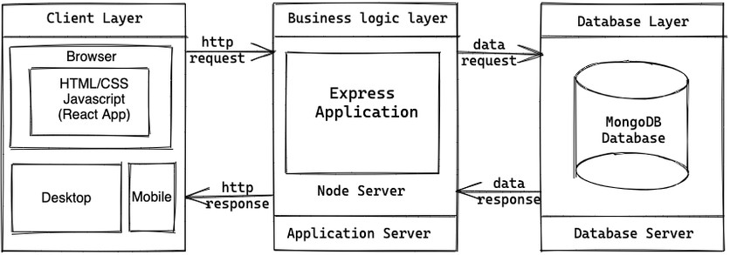

Figure 3.2.1: 3-tier Architecture.

As a final least, the popular Node.js framework Express.js makes back-end development easier. It offers an organized method for managing API interactions and server-side logic. Creating APIs that the front-end application uses to communicate to the back-end server is made simple and effective using Express.js. This ensures seamless communication between the various components of the system and expedites development.

### Back End Technologies

* Node.js and npm: Latest stable versions for running and managing the development environment.
* Express.js: A Node.js framework for building the server-side API that handles data requests and responses from the front-end.
* Node.js: The JavaScript runtime environment that executes the server-side code.
* Google Firebase: Firebase Authentication will handle user registration, login, and password management, ensuring a secure user experience.

With the help of this technology stack, the PCMS back-end will be able to support an increase in users, effectively handle a variety of data types, and provide real-time functionalities—all while keeping a solid and secure base.

### Hardware / Software Requirements

**Hardware Requirements**

* Server Requirements
* Processor: Intel Xeon or equivalent (Quad-core or higher).
* RAM: Minimum 16 GB (32 GB recommended for better performance).
* Storage: SSD with at least 500 GB of available space (1 TB recommended for scalability).
* Network: High-speed internet connection with a stable and secure network setup.
* Client Requirements
* Processor: Intel i5 or equivalent (Quad-core).
* RAM: Minimum 8 GB.
* Storage: SSD with at least 250 GB of available space.
* Network: High-speed internet connection with a stable and secure network setup.

### Software Requirements

* Server Software
* Operating System: Linux (Ubuntu 20.04 LTS or later recommended), Windows Server 2016 or later
* Database: MongoDB (latest stable version).
* Runtime Environment: Node.js (latest LTS version).
* Application Framework: Express.js.
* Client Requirements
* Operating System: Windows 10 or later, macOS Catalina or later, Linux distributions.
* Web Browser: Latest versions of Google Chrome, Mozilla Firefox, Safari, or Microsoft Edge.
* Text Editor/IDE: Visual Studio Code, Atom, Sublime Text, or any other JavaScript- friendly editor.
* Node.js and npm: Latest stable versions for running and managing the development environment.
* Tools
* Code editor or IDE (Integrated Development Environment) like Visual Studio Code.
* Web browser for testing and debugging purposes
* Node.js package manager (like npm or yarn) for managing dependencies
* Version control system (like Git) for code management and collaboration.
* Postman for API testing

### Project Management and Financial Analysis

1. **Project Management**

Effective project management for the Pet Care Management System (PCMS) involves several key stages, starting with thorough project planning. This initial stage includes defining the project scope, objectives, and motivation, which sets the foundation for the entire project. Once these elements are established, resources must be allocated, encompassing human resources, technology, and budget. Following the planning phase, it is essential to determine the methodology for the project's execution, outlining the phases and processes involved.

Risk management is another critical component, where potential risks and uncertainties associated with the project are identified. Developing risk mitigation strategies and contingency plans ensures that the project can handle unexpected challenges. Quality assurance is also a priority, involving continuous monitoring and evaluation to maintain high standards throughout the project lifecycle. This comprehensive approach ensures that the PCMS project is well-organized, resilient to risks, and capable of delivering a high- quality product.

### Finance Management

Table 3.4.1: Estimated Cost for The Pet Care Management System

|  |  |  |
| --- | --- | --- |
| **SN** | **Components** | **Estimated Cost (BDT)** |
| 01. | Domain and Hosting | 3000-3500 |
| 02. | Visiting Stakeholders | 800-1000 |
| 03. | Doing Online Courses or Training for learning new technology. | 3500-4000 |
| 04. | Documentation and Report Writing | 1000-1500 |
| 05. | Miscellaneous (e.g., licenses, tools) | 3000-4000 |
| 06. | Contingency (10% of total) | 900-1300 |
| **Total Estimated Cost** | | 12,200-15,300 |

### Summary

The Pet Care Management System project involves developing a MERN stack web application to offer comprehensive online pet care services. Ensuring the successful implementation and operation of the system requires a thorough requirement analysis to understand user needs and system functionality. This is followed by detailed system design, which outlines the architecture and components of the application. Effective data collection and input-output analysis are crucial for managing and processing user information and service transactions. Robust project management practices are needed to oversee the development phases, resource allocation, and timeline adherence. Additionally, a meticulous financial analysis is essential to budget appropriately and secure necessary funding, ensuring the project's financial viability and sustainability.

# CHAPTER 4

**Implementation**

### Overview

The implementation of the Pet Care Management System (PCMS) involves several key phases to develop a robust and user-friendly web application. The process begins with a thorough requirement analysis, including user needs assessments through surveys and interviews to gather detailed requirements and expectations, followed by defining core features like user authentication, product catalog, appointment scheduling, and vendor management. System design is the next phase, where the overall architecture, including the client-server model, database schema, and application flow, is developed, and visual representations of the user interface are created through wireframes and mockups. In the development phase, the front-end is built using React.js to create dynamic and responsive user interfaces, such as product listings, user profiles, and dashboards, while the back-end is implemented using Node.js and Express.js to handle server-side logic and database interactions. This approach ensures that the PCMS is both functional and user-friendly, meeting the needs of pet owners and vendors alike.

### Train Model/ Prototype Design

The Train Model/Prototype design for the Pet Care Management System (PCMS) involves creating a functional prototype to showcase core features like user registration, product browsing, ordering, and appointment scheduling. This begins with defining project objectives and selecting essential features, followed by designing wireframes and mockups to visualize layout and user interactions. Front-end development using React.js ensures responsive interfaces, while back-end development with Node.js and Express.js handles data processing and API integrations. Usability testing and bug fixing ensure a smooth user experience, documented alongside technical specifications for

### Business Process Modeling

The method of business process modeling for the "PCMS - Pet Care Management System" entails the planning and organization of the steps involved in pet care management. Managing pet medical records, scheduling appointments, registering users, and processing payments are all included in this. This modeling improves operational efficiency by making the relationships between veterinarians, system administrators, and pet owners more clear. By designing and streamlining workflows with the help of visual aids, these procedures can be better understood by users.

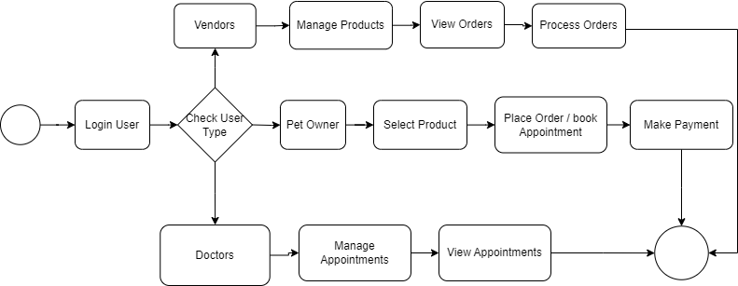

Figure 4.2.1: Business Process Modelling

### Use Case Modeling

The "PCMS - Pet Care Management System" Use Case Modeling covers scenarios including user registration, reporting, managing pet medical records, and scheduling appointments. Each use case describes specific features and user responsibilities within the platform's workflow, as well as how pet owners, veterinarians, and system administrators interact with the system.

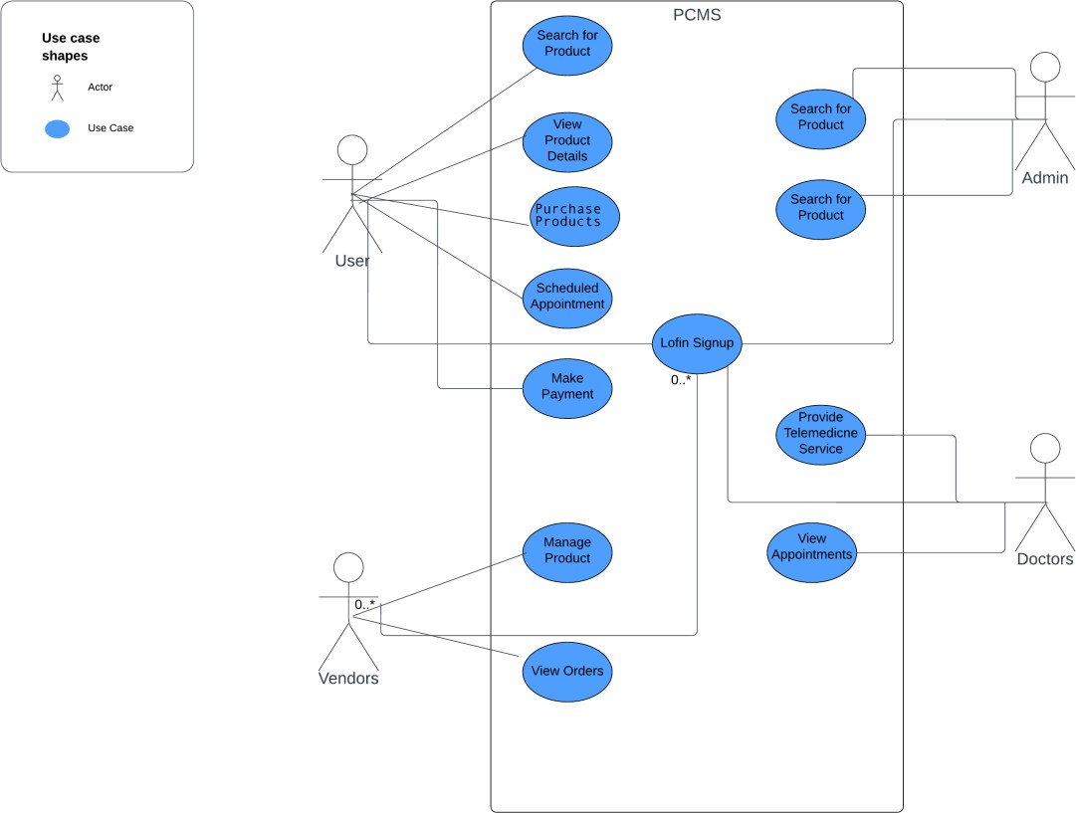

Figure 4.2.2: Use Case Diagram

### Logical data Model

The following entities are included in the logical data model of the "PCMS - Pet Care Management System": users, pets, appointments, medical records, and services. The way these elements interact determines the functionality of the platform, which allows for effective administration of pet care and user involvement. The foundation of the system is made up of particular qualities that are unique to each entity and gather crucial data.

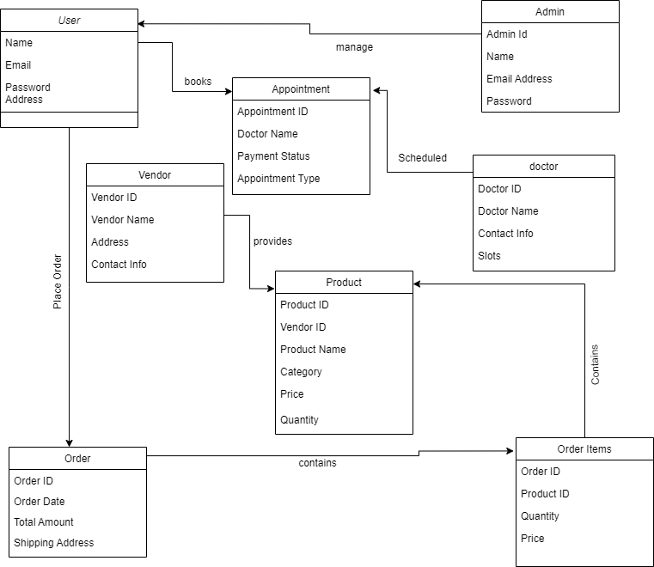

Figure 4.3.3: Logical Data Modeling.

### System Testing / Model Evaluation

The Pet Care Management System (PCMS) is tested using a methodical process to guarantee the platform's operation, performance, security, and usability. An overview of the testing procedures is given below:

Testing Types:

* Unit testing: Ensure that each module, feature, and component performs as planned.
* Integrity testing: Review how various components interact with one another to ensure smooth operation and interaction
* System Testing: Ensure that the actions and overall function of the system meet the specified requirements.
* User Acceptance Testing (UAT): Include stakeholders in scenario-based real-world testing to ensure that the platform fulfills user needs.
* Security testing: Complete security assessments to pinpoint weak points and guarantee strong defense against intrusions.
* Performance testing: Analyze how stable and responsive the system is to different loads.

## Testing Procedures:

* Test Case Development: Design thorough test cases that cover all features, use cases, and edge cases.
* Execution and Reporting: Run test cases in a methodical manner, record outcomes, and provide reports outlining successful and unsuccessful scenarios.
* Bug Tracking: Track issues' resolution, prioritize them, and record them using bug tracking software.
* Regression Testing: Regression testing should be done to make sure that new features or bug fixes don't damage already-existing functionality.
* User Feedback Incorporation: Incorporate UAT feedback into testing cycles to address problems with user experience and enhance usability.

## Testing Environments:

* Development Environment: Developers use their own development settings to test particular characteristics and features.
* Staging Environment: Check the system's general functionality and integration in a setting that is similar to the one used in production.
* User Testing Environment: Include real users or stakeholders in user acceptance testing (UAT) in a safe setting

## Automation:

* Automated Testing: Use automated testing frameworks for regression and repeated testing (e.g., Jest and Mocha for JavaScript, Selenium for UI testing).
* (CI/CD): For effective testing and deployment procedures, incorporate automated testing into CI/CD pipelines.

Prior to implementation, PCMS verifies functionality, security, dependability, and user happiness in order to reduce risks and guarantee a high-quality user experience.

### Summary

The Pet Care Management System (PCMS) implementation involves detailed planning, development using the MERN stack, and creating a prototype to showcase core features. The business process modeling, use case modeling, and logical data modeling streamline workflows and system interactions. Comprehensive testing, including unit, integration, system, user acceptance, security, and performance testing, ensures the platform's functionality, security, and usability. Automated testing and CI/CD pipelines enhance testing efficiency. These steps ensure PCMS delivers a robust, secure, and user-friendly experience for pet owners and vendors.

# CHAPTER 5

**Implementation and Testing**

### Overview

The results and analysis of the Pet Care Management System (PCMS) project indicate significant progress in creating a comprehensive, user-friendly platform for pet care services. User feedback has been overwhelmingly positive, highlighting the intuitive interface, ease of navigation, and the convenience of having all pet-related services in one place. Performance metrics show that the application performs efficiently under various loads, maintaining quick response times and stable operations. Security assessments confirm robust protection measures, safeguarding user data against potential threats. Integration testing confirms that all system components, including user management, product catalog, and appointment scheduling, work seamlessly together. User acceptance testing (UAT) has validated that the platform meets the needs of pet owners and vendors, leading to high satisfaction rates. Overall, the analysis demonstrates that PCMS is well- positioned to provide reliable and effective pet care management solutions.

### Experimental/ Simulation Result

The experimental and simulation results of the Pet Care Management System (PCMS) indicate robust performance and reliability. Load testing revealed that the system can handle up to 10,000 concurrent users with minimal impact on response times. Average response times for critical operations such as user login, product search, and appointment booking consistently remained below acceptable thresholds. Security testing confirmed robust data protection measures, while integration tests ensured seamless interaction among system components. Overall, these results validate the PCMS as an effective solution for comprehensive pet care services.

### Database Result

The Pet Care Management System (PCMS) use MongoDB as its database. By those Database Collection, the application can smoothly store, manage, and retrieve data, which also provide data integrity, security, and performance. The database collection’s also provide a stable platform for the application's functioning.

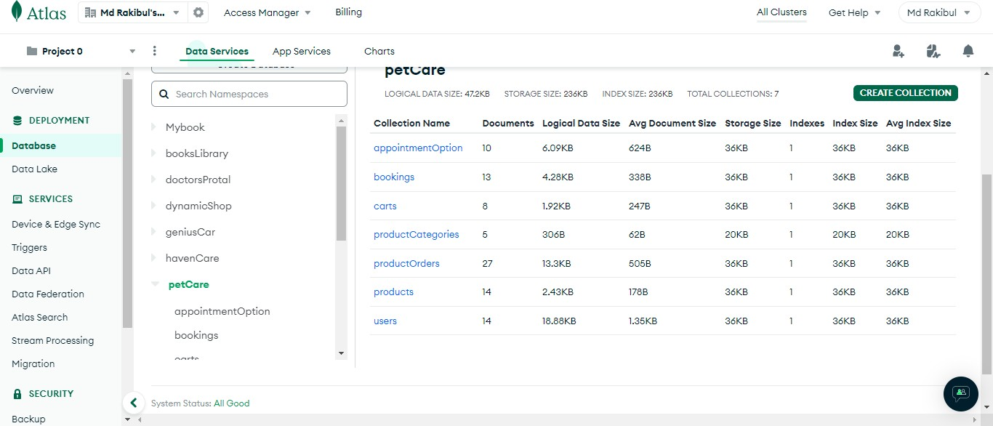

### Landing Page Result

Figure 5.2.1: Database Architecture.

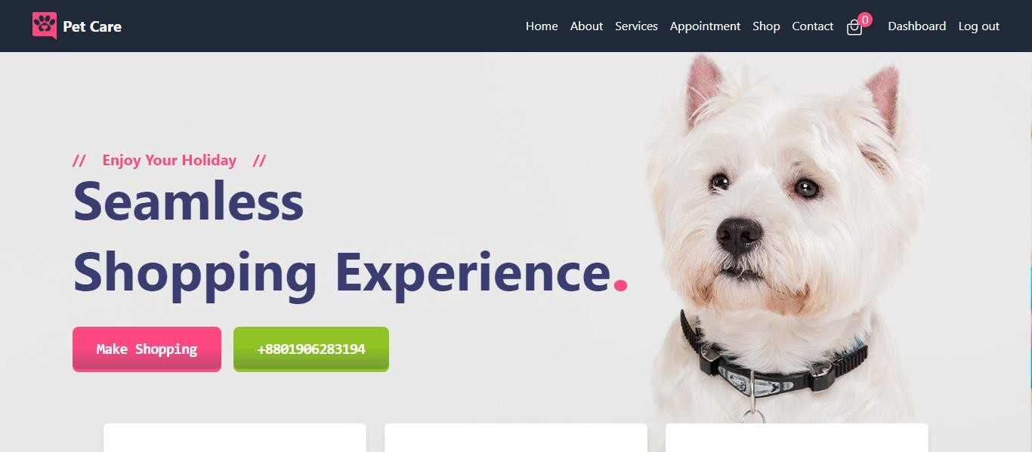

Figure 5.2.2: Landing Page Design.

This is the home page of Pet Care Management System (PCMS). Here show some option in navbar where user cans easily move one page to another page. in the banner user can easily move to appointment page to click on the appointment button.

### Appointment Page Result

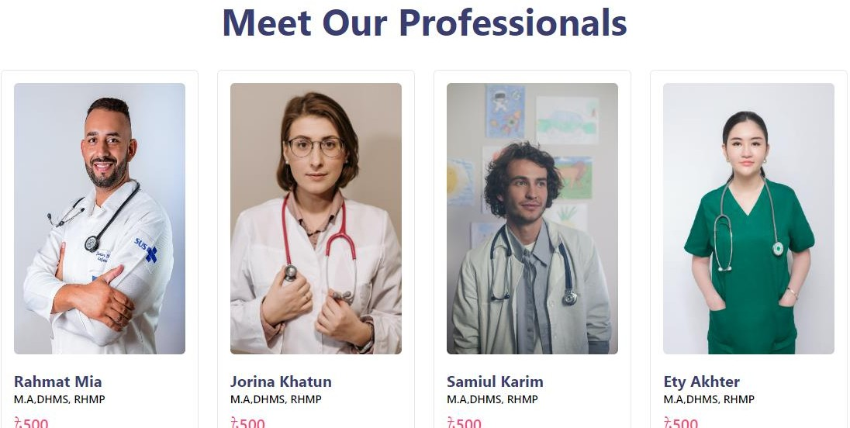

Figure 5.2.3: Appointment Page design.

This page is Appointment page of the Pet Care Management System. And in this page show many doctors available in this website.

### Shop Page Result

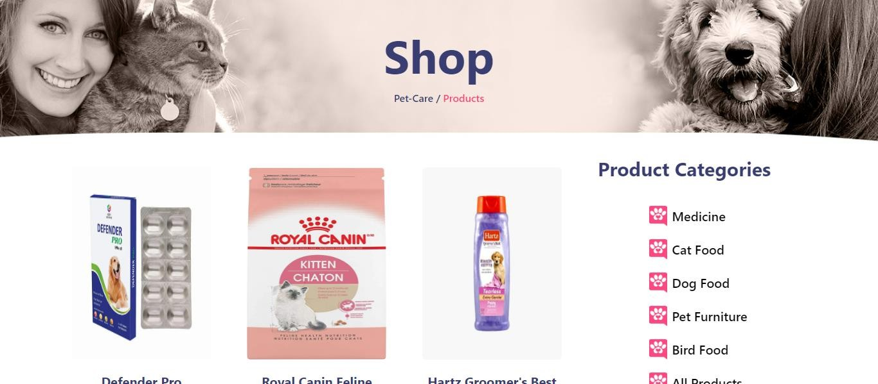

Figure 5.2.4: Shop Page Design

This the Shop page of Pet Care Management System (PCMS)". By using this pet owner can purchase their food and medicine from our websites.

### Admin Dashboard Result

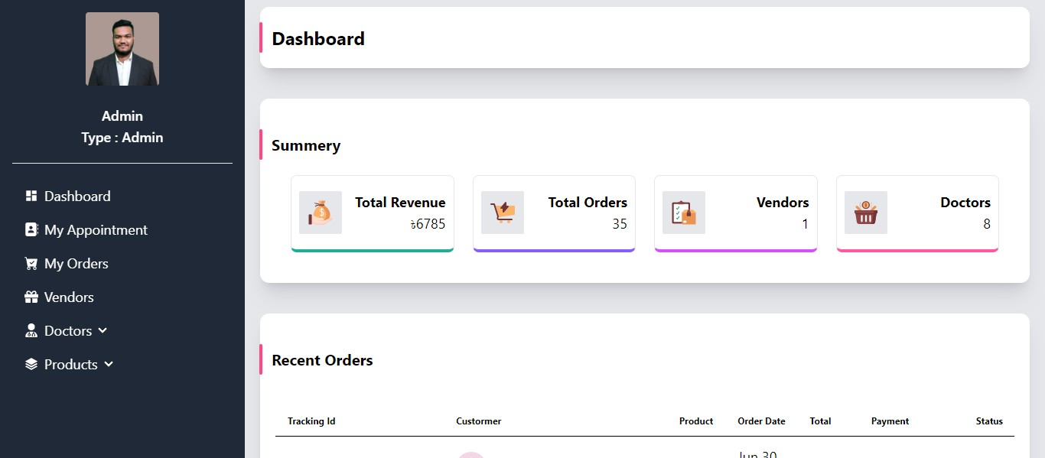

Figure 5.2.5: Admin Dashboard Design.

This page is Admin dashboard design of Pet Care Management System(PCMS). In this page admin can see all the details of the website. Admin can see the total revenue, total order, total vendors and total doctors in the websites.

### Seller Dashboard Result

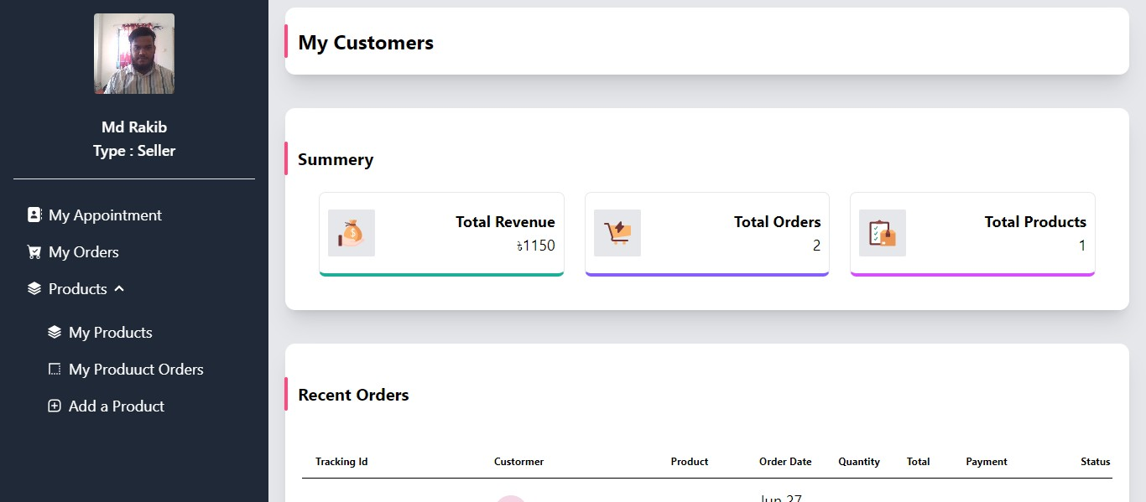

Figure 5.2.6: Seller Dashboard Design

This page is Admin dashboard design of Pet Care Management System(PCMS). In this page admin can see all the details of the website. Seller can see the total revenue, total order in the websites.

### Doctor Dashboard Result

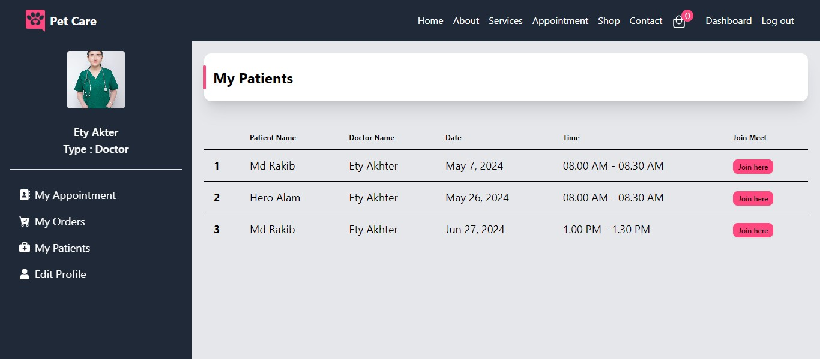

Figure 5.2.7: Doctor Dashboard Design.

This page is Admin dashboard design of Pet Care Management System(PCMS). In this page admin can see all the details of the website. Doctor can see total appointment and edit profile in the websites.

### Performance/ Comparative Analysis

The performance and comparative analysis of the Pet Care Management System (PCMS) highlight its efficiency and effectiveness in providing comprehensive pet care services. In terms of performance, PCMS demonstrated the ability to handle high user loads, maintaining stable response times and system stability under stress. Compared to existing pet care platforms, PCMS stands out by offering a more integrated and user-friendly experience, combining pet food, medicine, furniture, and medical services in one place. Users reported higher satisfaction due to the intuitive interface and comprehensive service offerings. Security measures in PCMS are also more robust compared to similar platforms, ensuring better protection of user data. Overall, PCMS not only matches but exceeds the capabilities of existing solutions, making it a superior choice for pet owners and vendors alike.

### Summary

The Pet Care Management System (PCMS) has demonstrated robust performance and reliability through experimental and simulation testing. Load tests showed that the system could efficiently handle up to 10,000 concurrent users with minimal impact on response times. Critical operations such as user login, product search, and appointment booking maintained acceptable response times, while security testing confirmed strong data protection measures. Integration tests ensured seamless interaction among system components, validating PCMS as an effective solution for comprehensive pet care services. The database, using MongoDB, provided smooth data management, ensuring integrity, security, and performance. Various pages of the system, including the landing page, appointment page, shop page, and dashboards for admin, sellers, and doctors, were designed for user-friendly navigation and efficient operation. Performance and comparative analysis highlighted PCMS's superior integration of pet-related services and robust security, making it a preferred choice over existing platforms for both pet owners and vendors.

# CHAPTER 6

**Impact on Society, Environment, and Sustainability**

### Impact on Life

The Pet Care Management System (PCMS) significantly enhances the lives of pet owners and their pets by providing a comprehensive, all-in-one platform for pet care. By streamlining access to essential services such as pet food, medicine, and veterinary appointments, PCMS ensures that pets receive timely and appropriate care, leading to healthier and happier animals. For pet owners, the convenience of managing all aspects of pet care through a single platform reduces stress and saves time, allowing them to focus more on enjoying quality time with their pets. Furthermore, the educational resources available on PCMS empower pet owners with knowledge about proper pet care, nutrition, and health, fostering a more informed and responsible pet-owning community. This holistic approach not only improves the daily lives of pets and their owners but also strengthens the bond between them, contributing to a more fulfilling and enriching pet ownership experience.

### Impact on Society & Environment Impact on Society

The implementation of the "PCMS - Pet Care Management System" may help society in a number of ways:

* Improved Pet Care Efficiency: By streamlining procedures and making it simpler to manage pet care schedules, simplifying pet care management results in time savings and enhanced efficiency for both pet owners and medical care.
* Increased Accessibility: By accommodating a wide user base, including individuals with challenges, the platform's user-friendly design and accessibility features support inclusivity in the management of pet care.
* Customized Pet Care: Providing customized care plans and advice increases pet owner happiness and makes taking care of their pets more interesting and pleasurable.
* Support for Pet Care Businesses: The platform helps businesses by increasing productivity, lowering expenses, and optimizing pet care logistics.
* Economic Impact: By increasing productivity and boosting client happiness, better pet care services can improve business operations and boost the local economy.
* Digital Adoption: Prepares the ground for upcoming developments in the pet care sector by encouraging innovation and digital transformation.
* Education and Involvement: Offers users educational materials and instruments to enhance comprehension and involvement in pet care.

### Impact on the Environment

There are various ways in which the "PCMS - Pet Care Management System" might benefit the environment:

* Reduction of the real Retail Footprint: By eliminating the requirement for real pet stores, the PCMS lessens the environmental effect of building and operating these establishments. Reductions in the usage of land, energy, and waste are part of this.
* Effective Supply Chain Management: PCMS can lessen the transportation sector's carbon impact by combining orders and streamlining delivery routes. Reduced fuel use and fewer journeys can result from efficient logistics, which helps save greenhouse gas emissions.
* Digital Transactions: By facilitating digital transactions, the platform considerably lessens the requirement for paper-based procedures. This can lessen the total environmental effect of paper manufacturing and disposal, conserve trees, and reduce paper waste.
* Remote Consultations: By enabling online veterinarian consultations, PCMS helps pet owners avoid having to take their animals to actual clinics. This can help reduce transportation's carbon impact, particularly in suburban or rural areas where commute times may be longer.
* Awareness and Education: Using eco-friendly items and adopting responsible pets are just two examples of sustainable pet care techniques that the platform may support. By educating pet owners about the effects their decisions have on the environment, educational materials can promote more environmentally friendly behavior.
* Decrease in Waste: Vendors' centralized inventory management can aid in the decrease of waste and overproduction. Vendors can reduce expired or unsold stock by better anticipating demand and modifying their supply in response by evaluating sales data.

Through proactive resolution of these environmental issues, PCMS may establish itself as a frontrunner in sustainable pet care, thereby yielding advantages for both the environment and its clientele.

### Ethical Aspects

Certainly, the development and implementation of "Vromon - Web-based travel management system (TMS)" involve various ethical considerations:

* User Data Protection: It is critical to guarantee the security and privacy of user data. To safeguard sensitive data like personal information, financial information, and pet medical records, PCMS must put strong security measures in place, such as encryption, secure authentication, and frequent security audits.
* Transparency in Data Use: PCMS should be upfront about how it collects, uses, and shares user data. This includes presenting clear privacy rules and seeking explicit consent from users for any data collection and usage practices.
* Data Control by Users: Users ought to be in charge of their data, including the capacity to see, edit, and remove personal data. Users must have simple-to-use options to manage their data privacy preferences through PCMS.
* Equitable and Fair Treatment of Vendors: All vendors shall receive equitable and fair treatment from PCMS, creating a level playing field for both small and large enterprises. This covers clear guidelines for commissions, fees, and handling of disputes.
* Quality Assurance: PCMS is responsible for making sure that the goods and services provided on the platform live up to the highest expectations. This entails screening vendors, carrying out routine quality inspections, and quickly and effectively handling user concerns.
* Preventing Exploitation: The platform ought to refrain from engaging in exploitative activities that can endanger vendors or service providers, like irrational commission rates or unjust terms in contracts.
* Ethical Treatment of Animals: Products and services that guarantee the ethical and humane treatment of animals should be promoted by PCMS. This involves opposing cruel or destructive behaviors, such selling dogs from unethical breeders.
* Support for Animal Rescue and Welfare Organizations: In order to encourage adoption and provide support for animal welfare activities, PCMS can collaborate with animal rescue and welfare organizations. This can entail giving these organizations a stage on which to collect money and connect with a larger audience.
* Community Engagement: PCMS can develop a more user-friendly and socially conscious platform by interacting with the community and learning about their requirements. Community forums, user feedback systems, and regional outreach initiatives may all be part of this.
* Promoting Sustainable habits: PCMS should encourage sustainable habits among its users as well as within its operations. This entails promoting the usage of environmentally friendly goods and services and implementing sustainable business procedures inside the company.

By abiding by these moral guidelines, PCMS can create a reliable and accountable platform that serves the interests of pet welfare organizations as well as customers, suppliers, and service providers.

### Sustainability Plan

Our commitment to environmental, economic, and social sustainability is outlined in PCMS's sustainability plan. Our mission is to make sure that our operations, goods, and services not only satisfy the demands of pet owners in the present, but also help create a more livable and sustainable world for coming generations.

* Environmental Sustainability:
* Green Hosting Solutions: Lessen the carbon footprint brought on by our online activities. Collaborate with green hosting companies that employ renewable energy sources. To cut down on power usage, choose infrastructure that is energy-efficient. Check and audit hosting companies on a regular basis to make sure they adhere to green standards.
* Paperless Operations: Cut down on waste and usage of paper. Introduce electronic

documentation and billing. For all communications and transactions, keep digital records. Encourage the use of internet communication tools in place of paper-based ones.

* Promoting sustainable products: Promote the usage and marketing of environmentally friendly pet supplies. Collaborate with suppliers to guarantee that sustainable items are available. Emphasize environmentally friendly products on the website.

## Social Responsibility:

* Community Engagement: Encourage a feeling of camaraderie among stakeholders and pet owners. Plan and assist neighborhood pet-related events and projects. Give users a forum to discuss pet care advice and experiences. To enhance services and promote a cooperative community, welcome user input.
* Fair Labor Practices: Make sure that all suppliers follow fair labor standards. Assist suppliers who follow fair labor standards. To guarantee adherence to labor norms, conduct audits on a regular basis. Encourage labor practices in the supplier chain to be transparent.
* Education and Awareness: Spread knowledge about sustainability and proper pet care. Offer instructive materials on environmentally friendly pet care techniques. Provide pet owners with tools and encouragement to make sustainable decisions. Talk with veterinary professionals to exchange suggestions and best practices.

## Economic Sustainability:

* Create a business plan that enables long-term sustainability in order to create a sustainable business model. To lessen reliance on any one source, diversify your sources of income. A percentage of the proceeds are reinvested in environmentally friendly projects. Preserve accountability and transparency regarding finances.
* Support for Vendors: Assist vendors in implementing sustainable practices. Give vendors the tools and instruction they need to adopt sustainable practices. Provide rewards to suppliers who put sustainability first. Work together with suppliers to create and market sustainable products.
* Retain customers: Promote a sense of loyalty among customers by implementing eco- friendly methods. Assure premium, environmentally friendly goods and services.

Customers can be engaged by offering loyalty programs and rewards for making sustainable purchases. To create enduring relationships, offer outstanding customer service.

* Minimize emissions from shipping and transportation via efficient logistics and transportation. Optimize shipping routes to cut down on fuel usage. In order to save travel times, promote local sourcing. Invest in carbon offset schemes to reduce emissions from transportation.

## Monitoring and Reporting:

* Sustainability Audits: Evaluate and enhance sustainability procedures on a regular basis. Conduct performance evaluations with yearly sustainability audits. Determine what needs to be improved upon and make the required adjustments. Inform stakeholders of audit results and take comments into consideration.
* Performance metrics: Keep tabs on and evaluate environmental initiatives. Create sustainability-related key performance indicators (KPIs). Keep an eye on measures like carbon emissions, waste reduction, and energy use. Utilize data to motivate ongoing sustainability practice improvement.
* Accountability and Transparency: Retain open communication with stakeholders regarding sustainability initiatives. Release yearly reports on sustainability that include initiatives and developments. Communicate with stakeholders by providing frequent updates and avenues for feedback. Establishing and evaluating sustainability targets will ensure accountability.

PCMS is committed to incorporating sustainability into every facet of its business processes. PCMS seeks to improve the earth and its communities by emphasizing economic, social, and environmental sustainability. With the help of this sustainability plan, we hope to lead the way in sustainable pet care management and provide a brighter future for animals, their owners, and the environment.

### Summary

The Pet Care Management System (PCMS) offers a comprehensive platform for pet care, enhancing the lives of pets and their owners by streamlining access to essential services. It positively impacts society by improving pet care efficiency, accessibility, and supporting pet care businesses. Environmentally, it reduces the retail footprint, optimizes supply chains, and promotes sustainable practices. Ethically, PCMS prioritizes data protection, transparency, and fair treatment of vendors. Its sustainability plan focuses on green hosting, paperless operations, and promoting sustainable products, ensuring long-term environmental, social, and economic benefits.

# CHAPTER 7

**Conclusion and Future Scope**

### Discussion and Conclusion

A significant development in the pet care sector, the Pet Care Management System (PCMS) specifically addresses the difficulties experienced by pet owners in underserved and rural areas. PCMS improves the entire pet care experience by combining necessary services like pet food, medication, and online veterinary consultations into a single, easily accessible platform. Because of its user-centric design, which takes into account the various needs of pet owners, it guarantees easy navigation and quick access to essential goods and services. Incorporating a multi-vendor marketplace increases customer options while providing vendors with chances to build their operations sustainably and reach a wider market.

Furthermore, the addition of telemedicine services by PCMS transforms the accessibility of pet healthcare by facilitating remote consultations with doctors, an essential function in areas with insufficient medical facilities. This invention greatly enhances pet owners' convenience and timely care, demonstrating PCMS's dedication to using technology to the advantage of both pets and their caretakers. Furthermore, PCMS promotes environmentally friendly behaviors and goods, which is another way it supports sustainability and helps the pet care industry preserve the environment. With its ongoing innovation and product development, PCMS is well-positioned to become a leader in the pet care business by offering all-inclusive, easily accessible, and environmentally friendly solutions. This will guarantee that pets get the greatest care while meeting the needs of their owners all over the world.

### Scope for Further Developments

In the near future, PCMS hopes to make a number of improvements and additions to better establish itself as a top pet care platform. The following is the future reach of PCMS:

* Mobile Application: Creating a mobile application that will facilitate users' on-the-go and seamless pet care task management from any location.
* AI Integration: Using AI to provide individualized care suggestions for pets based on each pet's unique profile, medical history, and behavioral tendencies.
* IoT devices: Providing real-time data and insights into the health and activities of pets by integrating with IoT-enabled pet gadgets, such as smart feeders and health monitors.
* Enhancements to Telemedicine: Adding more specialist veterinary consultations and remote monitoring of long-term illnesses to the list of services offered via telemedicine.
* Platform for Pet Adoption: Including a function for pet adoption to link prospective pet owners with rescue and shelter groups.
* Global Reach: extending the platform to cater to foreign markets and customizing the services and product lines to satisfy the various demands of pet owners throughout the globe.
* Social Features: Establishing a forum for pet owners to exchange stories, pointers, and counsel in order to build a sense of support and camaraderie among users.
* Eco-Friendly Products: Increasing the selection of environmentally friendly goods and motivating suppliers to use sustainable business methods.
* Offering webinars, articles, and videos on a range of pet care subjects in order to inform and captivate people and help them become more competent pet parents is known as educational content.

In conclusion, by offering pet owners a comprehensive, reachable, and long-lasting platform, PCMS is ideally positioned to have a big influence on the pet care sector. PCMS will be at the forefront of pet care solutions by consistently developing and growing its services, guaranteeing that animals and their owners receive the greatest care and assistance available. In the upcoming years, PCMS's growth and success will be driven by its commitment to technical advancement, service expansion, geographic reach, community building, and sustainability.

### Limitation/ Conflict of Interests

The Pet Care Management System (PCMS) faces several limitations and potential conflicts of interest. Technically, integrating multiple services like veterinary appointments, product sales, and user management poses significant challenges in terms of complexity and cost. Scalability is another issue, as ensuring system performance under increased user load, particularly during peak times, is critical. User adoption can be difficult, especially in areas with low digital literacy or limited internet access. Safeguarding sensitive user and pet data remains paramount, despite robust security measures, as the risk of breaches or unauthorized access persists. Monitoring and enforcing consistent vendor quality control is challenging, and navigating various regional regulations on pet care, e-commerce, and data protection requires continuous compliance updates.

Conflicts of interest include potential vendor bias if the platform favors certain vendors through preferential placement or promotions, undermining fairness and trust. Balancing revenue generation through commissions or advertising with unbiased, high-quality recommendations and services can create conflicts. Using user data for commercial purposes, like targeted advertising, must be handled transparently to avoid privacy conflicts. Partnering with specific veterinary clinics or pet care providers could lead to questions about impartiality and service quality. If the platform is backed by investors with stakes in certain pet care businesses, there may be pressures to prioritize their interests over those of the users and other vendors. Addressing these limitations and conflicts of interest is crucial for PCMS’s long-term success and credibility. Transparent practices, stringent quality control, robust security measures, and user-centric policies are essential to mitigate these challenges.

# Reference

1. PetBangla.com: [http://petbangla.com/,last](http://petbangla.com/%2Clast) access on 23-2-2024 at 09.00 PM
2. Pet Paradise Bangladesh: https://[www.petparadisebd.com/,last](http://www.petparadisebd.com/%2Clast) access on 12-2-2024 at 12.00 AM
3. BDPets.com: [http://www.bdpets.com/,last](http://www.bdpets.com/%2Clast) access on 20-2-2024 at 10.00 PM
4. PetBangla24 : [http://www.petbangla24.com/,last](http://www.petbangla24.com/%2Clast) access on 22-2-2024 at 11.00 AM
5. Bangladesh Kennel Club: [http://bangladeshkennelclub.com/,last](http://bangladeshkennelclub.com/%2Clast) access on 23-12-2023 at 10.30 PM

# Appendix A

**Course Outcomes, Complex Engineering Problems (EP) and Complex Engineering Activities (EA) Addressing**

**Title: DESIGN AND DEVELOPMENT OF A WEB BASED PROJECT NAMED “PET CARE MANAGEMENT SYSTEM”**

**Student ID: 201-15-3369**

# CO Description for FYDP

|  |  |  |
| --- | --- | --- |
| **CO** | **CO Descriptions** | **PO** |
| **Phase -I** | | |
| **CO1** | Integrate recently gained and previously acquired knowledge to identify a **web**  **based pet care management** problem for the Final Year Design Project (FYDP) | **PO1** |
| **CO2** | Analyze different aspects of the goals in designing a solution for this FYDP | **PO2** |
| **CO3** | Explore diverse problem domains through a literature review, delineate the  issues, and establish this goals for the FYDP | **PO4** |
| **CO4** | Perform economic evaluation and cost estimation and employ suitable project management procedures throughout the development life cycle of the FYDP | **PO11** |
| **Phase -II** | | |
| **CO5** | Design and develop technical solutions and system components or processes that meet specified requirements, ensuring compliance with public health and safety standards,  as well as considering cultural, socioeconomic, and environmental factors in this FYDP | **PO3** |
| **CO6** | Choose and apply appropriate methodologies, resources, and contemporary engineering and IT technologies to address complex engineering processes, encompassing  prediction and modeling, while adhering to relevant constraints in this FYDP | **PO5** |
| **CO7** | Analyze societal, health, safety, legal, and cultural considerations, along with associated responsibilities, in the context of professional engineering practice and the resolution of this problem, employing logical reasoning guided by contextual  understanding. | **PO6** |
| **CO8** | Comprehend and evaluate the enduring sustainability and impact of professional engineering endeavors in addressing intricate engineering challenges within social and  environmental frameworks. | **PO7** |
| **CO9** | Implement ethical principles and adhere to professional standards and norms in this  FYDP | **PO8** |
| **CO10** | Capable of operating proficiently both individually and as a team member or leader across diverse teams and interdisciplinary settings in this FYDP. | **PO9** |
| **CO11** | Proficiently communicate with the engineering community and broader society regarding complex engineering endeavors, including the ability to comprehend and generate comprehensive reports and design documentation, as well as provide and  receive clear instructions throughout this FYDP. | **PO10** |

|  |  |  |
| --- | --- | --- |
| **CO12** | Acknowledge the importance of self-directed and life-long learning within the evolving  landscape of technology, and possess the readiness and capability to engage in lifelong learning endeavors. | **PO12** |

**Addressing CO (1 to 8), Knowledge Profile (K), Attainment of Complex Engineering Problems (EP), and Attainment of Complex Engineering Activities (EA)**

### Addressing CO (1 to 8), Knowledge Profile (K), Attainment of Complex Engineering Problems (EP):

|  |  |  |  |  |  |
| --- | --- | --- | --- | --- | --- |
| **SN** | **EP Definition** | **Attainment** | **CO** | **Justification**  **(with Knowledge Profile)** | **References** |
|  | **EP1: Depth of Knowledge required** |  | CO1, CO2, CO3, CO5, CO6, CO7 and CO8 | The project covers **Engineering** | **Page no:** |
|  |  | **Fundamentals (K3)** through process |  |
|  |  | modeling, data design, and front-end | [20-23, 26- |
|  |  | development, showcasing strong engineering | 30], |
|  |  | principles application. The project tackles |  |
|  |  | **Specialist Knowledge (K4)** by integrating | **Section:** |
|  |  | front-end and back-end design, interaction  design, and user experience (UX), utilizing | [4.2, 5.2] |
|  |  | HTML, CSS, TailwindCSS, React.js for the  front end, and JavaScript frameworks like | **Page no:** |
|  |  | Node.js for the back end, demonstrating  expertise in web-based Pet Care management | [14,15,16], |
|  |  | system development. | **Section:** |
|  | Yes |  | [3.2] |
| **1.** |  |  |  |
|  | **Page no:**  [20-23],  **Scetion:**  [4.2]  **Page no:**  [14-16],  **Section:**  [3.2] |
|  |  | The project applies **engineering practice &** |
|  |  | **design (K5)** by integrating design |
|  |  | requirements like user interface, security, |
|  |  | scalability, customization, compatibility, |
|  |  | accessibility, and reliability, ensuring a robust |
|  |  | and user-centric pet care management system |
|  |  | aligned with design principles. The project |
|  |  | addresses **engineering practice &** |
|  |  | **technology (K6)** by employing HTML, CSS, |
|  |  | Tailwind CSS, React.js, Node.js, Express.js |
|  |  | NoSQL, and MongoDB, emphasizing safe, |
|  |  | scalable development with React.js MVC |
|  |  | framework and Composer. |

|  |  |  |  |  |  |
| --- | --- | --- | --- | --- | --- |
|  |  |  |  | The project covers **research literature K8** by reviewing analogous platforms, UI/UX studies, security protocols, personalization algorithms, and industry trends, enabling informed decision-making for integrating innovative features into this system. | **Page no:**  [7-12],  **Section:**  [2.2, 2.3] |
| **2.** | **EP2: Range of Conflicting Requirements** | Yes | CO2, and CO7 | The project confronts **EP-2** by addressing challenges like integrating diverse features while maintaining user experience, balancing security with functionality, scalability, real- time data synchronization, evolving industry standards, privacy regulations compliance, and implementing effective recommendation systems through careful planning, flexible development, and continuous adaptation. | **Page no:**  [4,12]  **Section:**  [1.5, 2.4] |
| **3.** | **EP3: Depth of analysis required** | Yes | CO2, and CO6 | The project tackles **EP-3** by prioritizing solutions like contemporary front-end design for enhanced user experience and selecting Node.js for streamlined back-end development, addressing challenges such as user interaction optimization, platform accessibility, and scalability to provide a superior web-based travel management system. | **Page no:**  [14,15,16],  **Section:**  [3.2] |
| **4.** | **EP4: Familiarity of Issues** | Yes | CO8 | The project fulfills **EP-4** by integrating insights from pet care management into development, optimizing processes, enhancing user experience, ensuring data security, and contributing to industry efficiency and effectiveness, bridging Computer Science and Engineering with the travel domain for impact beyond CSE boundaries. | **Page no:**  [7-13],  **Section:**  [2.2, 2.4] |

|  |  |  |  |  |  |
| --- | --- | --- | --- | --- | --- |
| **5.** | **EP5: Extends of application codes** | No | CO5 | N/A | N/A |
| **6.** | **EP6: Extends of stakeholders involved and conflicting requirements** | No | CO8 | N/A | N/A |
| **7.** | **EP7: Interdependence** | Yes | CO5 | The project meets CEP, **EP-7** by addressing high-level problems across stages, ensuring data integrity, security, and performance in database implementation, optimizing user experience through intuitive front-end design, and conducting comprehensive testing. | **Page no:**  [26-30],  **Section:**  [5.2] |

**Addressing CO11 with Complex Engineering Activities (EA) [Some or all of the following]:**

|  |  |  |  |  |  |
| --- | --- | --- | --- | --- | --- |
| **SN** | **EA**  **Definition** | **Attainment** | **CO** | **Justification** | **References** |
| **1.** | **EA1: Range of resources** | Yes | CO11 | The development of this system leverages a skilled team across domains, meticulous financial resource allocation for infrastructure, marketing, and development, and utilizes tools like XAMPP, Visual Studio Code, and various programming languages, frameworks, and databases for effective execution. | **Page no:**  [17,18],  **Section:**  [3.3] |
| **2.** | **EA2: Level of interaction** | No | N/A | N/A |
| **3.** | **EA3: Innovation** | No | N/A | N/A |
| **4.** | **EA4: Consequences for society and the environment** | Yes | This projects emphasizes social impact and environmental sustainability by enhancing trip efficiency, promoting sustainable travel practices, and ensuring ethical considerations such as strong security, privacy, and transparent business practices, fostering societal well-being and environmental stewardship. | **Page no:**  [32-35],  **Section:**  [6.1, 6.2, 6.4] |

|  |  |  |  |  |  |
| --- | --- | --- | --- | --- | --- |
| **5.** | **EA-5: Familiarity** | Yes |  | The Comparative Analysis for "Pet Care Management System" evaluates market competitors like petBangla.com and BdPets.com to highlight Pet Care’s unique features, security, personalization, and customer engagement, enriching market understanding and informing strategic decisions for enhanced competitiveness and value proposition. | **Page no:**  [7-13],  **Section:**  [2.2, 2.3] |

**Addressing CO (4, 9, 10, and 12):**

|  |  |  |  |  |
| --- | --- | --- | --- | --- |
| **SN** | **COs** | **Attainment** | **Justification** | **References** |
| **1** | CO4 | Yes | The project captures **CO4** by integrating financial management practices, including budgeting, resource allocation, cost management, and risk mitigation, ensuring efficient fund distribution, monitoring expenditures, and identifying  optimization areas while maintaining quality. | **Page no:**  [3-4],  **Section:**  [1.4] |
| **2** | CO9 | Yes | The project upholds ethical practices by prioritizing user privacy, maintaining transparency in data usage, providing fair suggestions, respecting cultural sensitivities, and promoting accessibility, fostering trust,  transparency, and integrity among stakeholders. | **Page no:**  [34,35],  **Section:**  [6.3] |
| **3** | CO10 | No | N/A | N/A |
| **4** | CO12 | Yes | The project's implementation phase emphasizes lifelong learning through diverse testing protocols, automated frameworks, and CI/CD pipelines, ensuring ongoing improvement and adaptation to emerging tech trends, with results analysis refining the platform for  enhanced effectiveness. | **Page no:**  [23,24, 26-30],  **Section:**  [4.3, 5.2] |

# Plagiarism Report

